**1. INTRODUCTION**

In today's information age, libraries play a crucial role in fostering knowledge, education, and entertainment. However, managing a vast collection of books, periodicals, and other resources can be a complex task. This library management system addresses this challenge by providing a user-friendly and efficient solution for libraries of all sizes.

* **Simplify Book Management:** Catalogue and organize library resources with ease, including books, audiobooks, DVDs, and more.
* **Enhanced Search Capabilities:** Find the perfect book or resource in seconds with powerful search filters and a user-friendly interface.
* **Streamlined Borrowing and Returns:** Manage borrowing and returns efficiently, eliminating manual processes and queues.
* **Real-Time Availability:** Stay informed about book availability and receive notifications when requested materials are ready for pickup.
  1. **Objectives:**

The objectives of a Zoo Management System (ZMS) PHP project typically include:

1. **Increase Operational Efficiency:** Automate workflows for book acquisition, cataloguing, borrowing, returns, and other library operations, reducing manual labour and saving time.
2. **Enhance Resource Accessibility:** Facilitate efficient search and retrieval of library materials through user-friendly search interfaces and intuitive browsing capabilities.
3. **Improve User Experience:** Provide a streamlined and user-friendly interface for patrons to manage their borrowing experience, including account management, reservation requests, and overdue notifications.
4. **Promote Resource Discovery:** Employ powerful search functions and personalized recommendations to help users discover relevant and engaging library resources.
5. **Increase Borrowing Rates:** Make borrowing and returning resources faster and more convenient, leading to increased borrowing and circulation.
6. **Reduce Loss and Damage:** Implement loan period tracking and reservation alerts to minimize the loss or damage of library materials.

**2. SYSTEM ANALYSIS**

**2.1 Existing system:**

The existing system for library management typically involves manual processes and may lack integration and efficiency in managing various aspects of library operations. Here are some key characteristics of the existing system:

1. **Manual Record-Keeping**: Many libraries rely on paper-based systems or basic spreadsheets to manage book records, user information, and transaction logs.
2. **Limited User Interaction**: Information for users, such as book availability, due dates, and library events, may be available in printed formats or basic websites.
3. **Fragmented Data Management**: Data related to book inventory, user details, transaction histories, and library events may be stored in separate systems or documents, making it difficult to obtain comprehensive insights and reports.
4. **Time-Consuming Administrative Tasks**: Library staff spend a significant amount of time on routine administrative tasks such as checking books in and out, managing overdue fines, and updating user records.

**2.2 Proposed system:**

The proposed system for the library management system aims to overcome the limitations of the existing system by introducing a comprehensive, integrated, and user-friendly platform. Here are the key components and features of the proposed library management system:

1. **Centralized Dashboard for Administration**: A robust admin dashboard providing library administrators with a centralized platform to manage all aspects of library operations. This includes book records, user information, transaction logs, and event scheduling.
2. **User Portal for Enhanced Interaction**: A user portal offering interactive features such as book searches, personalized book recommendations, online reservations, due date notifications, and fine payments with integrated payment gateways for seamless transactions.
3. **Comprehensive Book Database**: A centralized database storing detailed information about library books, including titles, authors, genres, availability, and borrowing histories. This supports efficient cataloguing, inventory management, and user access to the library's collection.
4. **Staff Management Tools**: Tools for managing employee schedules, task assignments, and internal communication to streamline operations and enhance coordination among library staff.
5. **Enhanced Communication Channels**: Integrated communication channels such as email notifications and in-app messages to inform users about new arrivals, upcoming events, overdue books, and other important updates.
6. **Efficient Resource Management**: Tools for managing the reservation and usage of library resources like study rooms, computers, and event spaces. This ensures optimal utilization and reduces conflicts in resource scheduling.

**3. SYSTEM REQUIREMENT SPECIFICATION**

**3.1 Introduction:**

Software Requirement Specification is a document that completely describes what the proposed software will do. Software Requirement Specification fully describes the external behaviour of the application or the subsystem identified. It also describes non-functional requirements design constraint and other factor necessary to provide a complete and comprehensive description of the requirements of the software. Identifying requirements necessarily involving specifying what some client has in their mind. For just automating existing manual system requirement have to visualized and created.

**3.2 Purpose:**

The major purpose of the software requirement specification is to specify all the requirement of the proposed software. It describes external behaviour of the system. It describes the external requirements for the software system. It also describes the interface required for the system

**3.3 Scope:**

The SRS document will be the basis for final software system. This software developed using this SRS document provide menu interface for applying various graphical application. This SRS document can be used to validate the final product.

**3.4 Software Requirements:**

* + Operating system: Windows 10 or above
  + Development Tools: Visual studio code.
  + Browser: Google Chrome or any other browser.

**3.5 Hardware Requirements:**

* + Hard Disk: 500GB or Above
  + RAM: 4GB or Above

**3.6 Module Specification:**

There are six modules in the proposed library management system application:

1. **Dashboard Module**: This module provides an overview of the library's operations, including statistics on book inventory, issued books, and user activities. It offers quick access to key functionalities and displays important notifications and updates.
2. **Issue Book Module**: In this module, users can issue books to library members. It allows staff to search for available books, select a user, and record the issuance details, including the due date. The module ensures that the book's availability is updated in real-time.
3. **Return Book Module**: This module manages the return of issued books. It allows staff to record the return of books, check for any overdue fines, and update the book's status in the inventory.
4. **View Issued Books Module**: This module provides a comprehensive view of all issued books, including details such as the book title, user information, issue date, and due date. It allows staff to filter and search through the issued books based on various criteria.
5. **Manage Books Module**: In this module, library administrators can manage the book inventory. It includes functionalities for adding new books, updating existing book details, and removing books from the catalogue. The module also tracks the number of available copies and issued copies.
6. **Manage Users Module**: This module allows administrators to manage library users. It includes functionalities for adding new users, updating user information, and removing users. The module also keeps track of the number of books issued to each user and their transaction history.

**3.7 Languages:**

1. **Electron**: Electron is a framework that allows developers to build cross-platform desktop applications using web technologies like HTML, CSS, and JavaScript. It leverages the Chromium rendering engine and Node.js runtime, enabling developers to create desktop apps that look and feel like native applications.
2. **React**: React is a JavaScript library for building user interfaces, developed and maintained by Facebook. It follows a component-based architecture where UIs are divided into reusable components, each responsible for rendering a part of the UI.
3. **Material-UI (MUI)**: Material-UI is a React UI framework that implements Google's Material Design principles. It offers a set of customizable and responsive components, including buttons, forms, navigation bars, and more, designed to provide a consistent and visually appealing user experience.
4. **Node.js**: Node.js is a runtime environment that allows JavaScript code to run outside of the browser, typically on the server-side. It uses an event-driven, non-blocking I/O model that makes it lightweight and efficient for building scalable network applications. Node.js is built on the V8 JavaScript engine and provides a rich set of built-in modules and a vast ecosystem of open-source libraries through NPM (Node Package Manager).
5. **Socket.IO**: Socket.IO is a JavaScript library that enables real-time, bidirectional communication between web clients and servers. It abstracts the complexity of WebSocket’s and fallbacks to other transport mechanisms like AJAX long polling, enabling real-time features such as chat applications, multiplayer games, and live data streaming.
6. **Express**: Express is a minimalist and flexible web application framework for Node.js, designed to simplify the development of web and mobile applications. It provides essential features like routing, middleware support, and template engines, allowing developers to build robust APIs and server-side applications quickly.
7. **TypeScript**: TypeScript is a typed superset of JavaScript that compiles to plain JavaScript. It adds optional static types, interfaces, generics, and other advanced features to JavaScript, enhancing code quality, readability, and maintainability. TypeScript helps catch errors during development, provides better tooling support through intelligent code completion and type checking, and enables code refactoring with confidence.

**4. SYSTEM DESIGN**

**4.1 Introduction**:

The design activity starts when the SRS for the software to be developed is available. Design document includes the system specification as well as design of specifications and the actual programs. The design of the system is essentially a blue print or plan for the system. The goal of the design process is not simply to produce a design for the system. Instead the goal is to find the best possible design within limitations imposed by the requirements and the physical and social environment in which the system will operate. The design process for the software system has two levels.

**4.2 Use Case Diagram:**

A use case diagram is a type of Unified Modelling Language (UML) diagram that provides a visual representation of the interactions between actors and a system. The purpose of a use case diagram is to model the functionality of a system and to identify the requirements for that system. In a use case diagram, the actors are represented as stick figures and the system is represented as a rectangle.

**4.3 Use case components:** 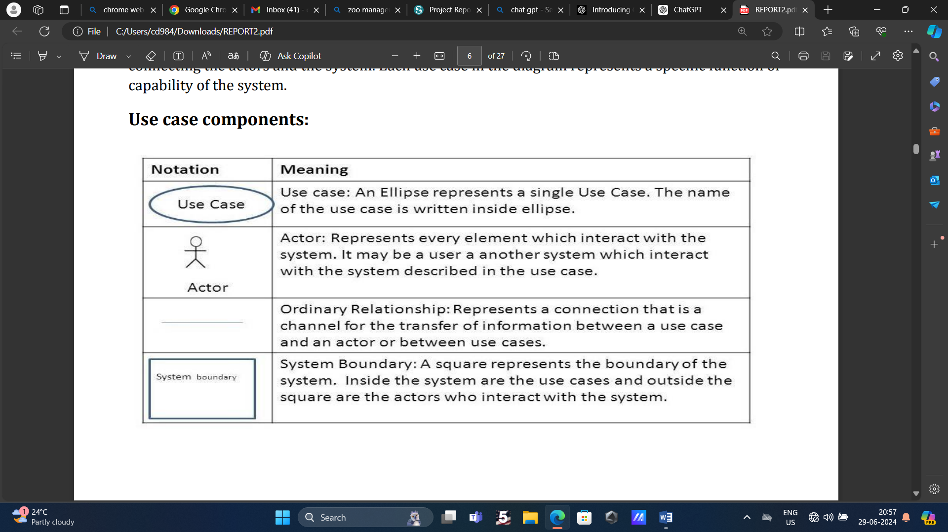

**4.4: Use Case Diagram:**

**Admin**

Figure 4.4.1: Use Case Diagram

**4.5 Data Flow Diagram**:

A data flow diagram (DFD) is a type of diagram that represents the flow of data within a system. It is used to model the movement of data between different components of a system and to show the transformations that data undergoes as it moves through the system.

A DFD consists of symbols that represent the components of a system and arrows that represent the flow of data between these components. The components are typically represented as boxes, while the data flows are represented as arrows with the direction of flow indicated by the arrowhead. There are different levels of detail that can be represented in a DFD, ranging from a high- level overview to a detailed representation of the system.

DFDs are useful for understanding the flow of data within a system and for identifying areas where data may be redundant, missing, or incorrect. They are also useful for communication and collaboration between stakeholders, including developers, business analysts, and end-users.

**4.5.1 Flow Diagram Notations:**

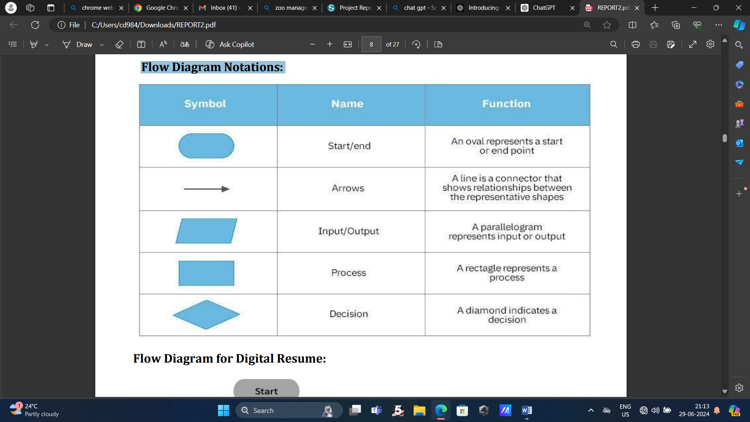

Figure 4.5.1.1: Flow Diagram Notations

**4.5.2 DFD for Library Management System**

Data Flow Diagram (DFD) depicts the flow of information and the transformation applied when data moves in and out of a system. The overall system is represented and described using input, processing, and output in the DFD. The inputs can be:

* **Book request** when a student requests for a book.
* **Library card** when the student has to show or submit his/her Identity as proof.

The overall processing unit will contain the following output that a system will produce or generate:

* The book will be the output as the book demanded by the students will be given to them.
* Information on the demanded book should be displayed by the library information system that can be used by the student while selecting the book which makes it easier for the student.

1. **Level 0 DFD –**

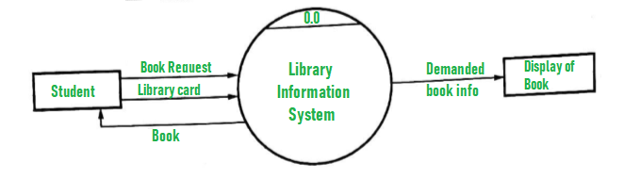

Figure 4.5.2.1: Flow Diagram for Library Management System

1. **Level 1 DFD –**

At this level, the system has to show or exposed with more details of processing. The processes that are important to be carried out are:

* Search by Book, Autor, ID

List of authors, List of Titles, List of Topics, the bookshelves from which books can be located are some information that is required for these processes. **Data store** is used to represent this type of information.

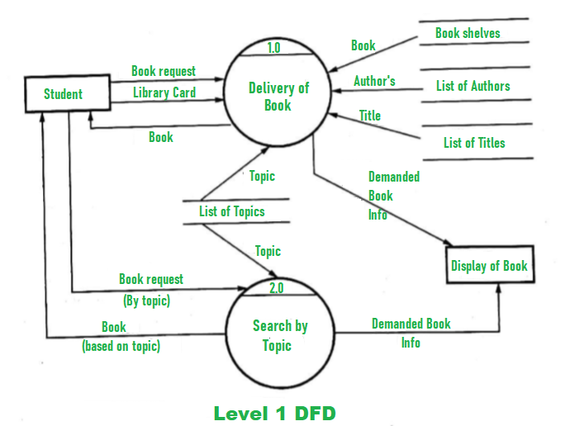

Figure 4.5.2.2: Flow Diagram for Library Management System

1. **Level 2 DFD –**

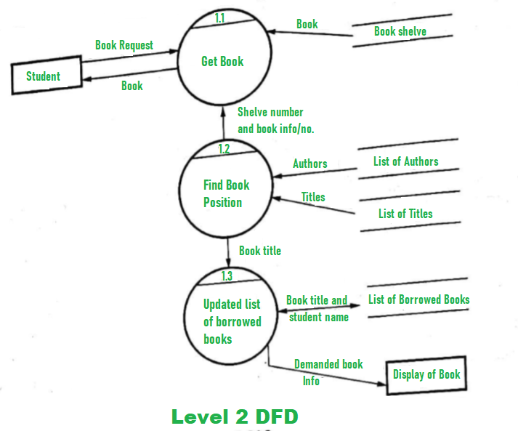

Figure 4.5.2.3: Flow Diagram for Library Management System

**5. IMPLEMENTATIONS**

**5.1 CODING**

**5.2 Screen Shots**

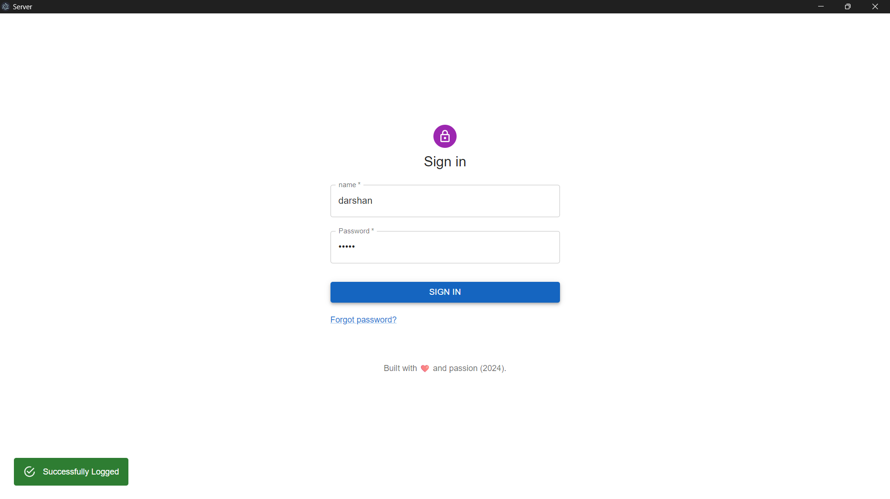

Figure 5.2.4: Admin login

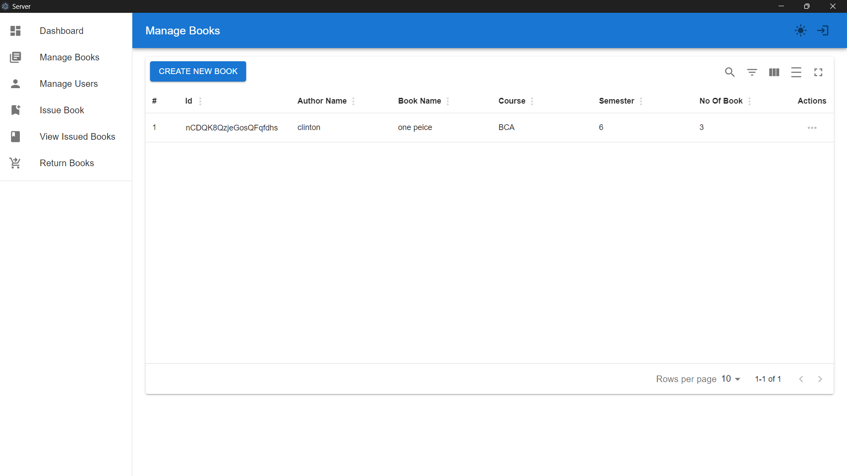

Figure 5.2.4: Admin Interface

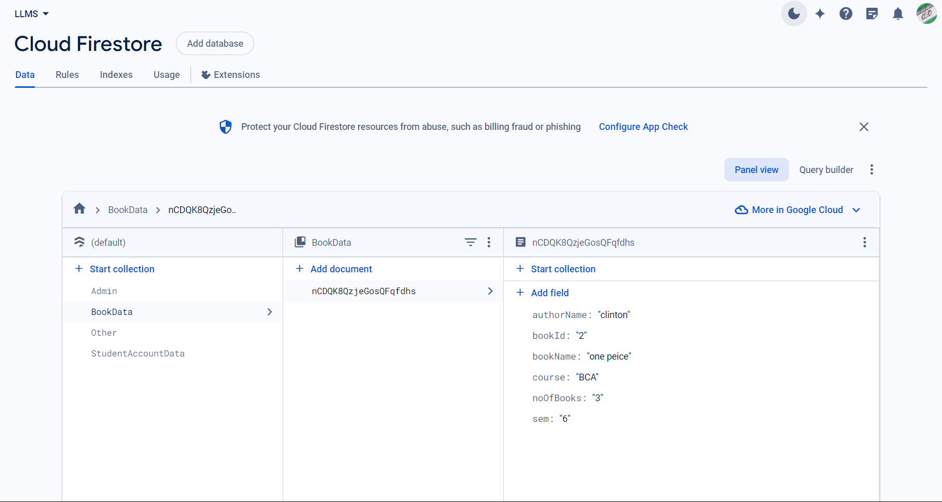

Figure 5.2.5: Database Structure

**6. TESTING**

Testing is the major quality control measure used software development. Its basic function is to detect errors in the software. Thus, goal of testing it so uncover requirement, design and coding errors in the program.

**6.1 Unit Testing**

It is a starting point of testing. In this, a module is tested separately and is after performed by the coder himself simultaneously along with the coding of the module.

**6.2 Integration Testing**

The modules gradually integrated into subsystems, which are then integrated to eventually form the entire system. During integration of modules, integration testing is performed to detect design errors by focusing on testing the interconnection between modules.

**6.4 Acceptance Testing**

this testing is performed to demonstrate to the client, on the real-life data of the client, the operation of the system.

**6.5 Testing for login**

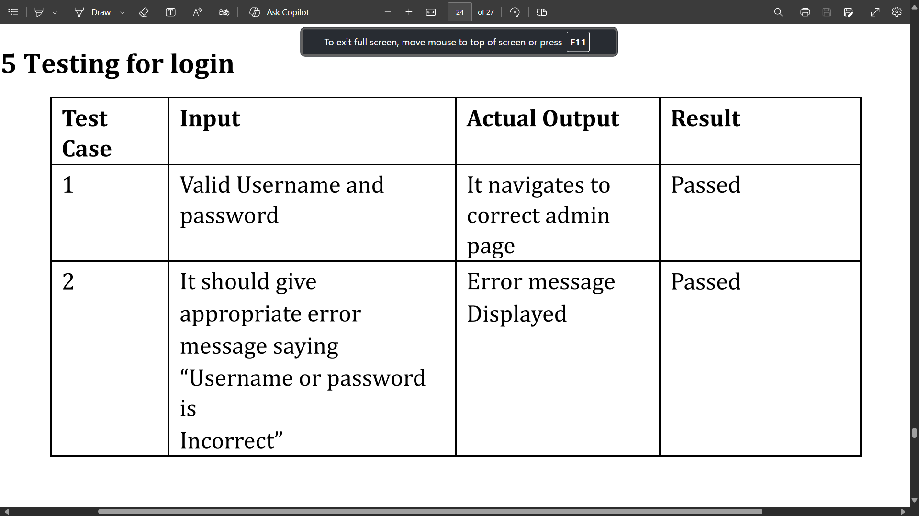

**7. CONCLUSION**

The project titled **Library Management System** was meticulously studied and analysed to design, code, and implement an effective solution. The development process was conducted under the guidance of an experienced project advisor. Throughout the project duration, all current requirements and possibilities were carefully considered to ensure the system's robustness and usability.

**Library Management System** is an Electron-based application designed to manage various aspects of a library efficiently. It facilitates book issuance, returns, user management, and inventory management through a user-friendly interface. This system streamlines library operations, reduces manual work, and enhances the overall user experience.

The development included key features such as a centralized dashboard, interactive book management, user management, and real-time data processing with integrated tools like React, Material-UI, Node.js, Socket.IO, and TypeScript. The successful implementation of this project provides a solid foundation for future enhancements and scalability, ensuring that the library can efficiently manage its resources and serve its patrons effectively.

**8. FUTURE SCOPE**

The future scope of the **Library Management System** project includes several potential enhancements and innovations that can further improve the system's efficiency, user experience, and overall functionality. Here are some key areas for future development:

1. **Mobile App Integration:**
   * Developing dedicated mobile applications for iOS and Android platforms to provide users with on-the-go access to library services, such as searching for books, reserving books, viewing borrowing history, and receiving notifications for due dates and new arrivals.
2. **Integration with Online Databases:**
   * Connecting the library management system with online databases and digital libraries to provide users with access to a wider range of resources, including e-books, research papers, and journals. This can significantly expand the library's collection without physical constraints.
3. **Enhanced Analytics and Reporting:**
   * Implementing advanced analytics tools to provide deeper insights into user behavior, book popularity, borrowing trends, and resource utilization. This data can help library administrators make informed decisions about resource allocation and collection development.
4. **Automated Inventory Management:**
   * Utilizing RFID technology for real-time tracking of books and other resources within the library. This can streamline the process of inventory management, reduce the time required for stocktaking, and minimize the risk of lost or misplaced items.
5. **User Personalization and Recommendations:**
   * Incorporating machine learning algorithms to offer personalized recommendations to users based on their borrowing history, reading preferences, and search patterns. This can enhance user engagement and satisfaction.
6. **Enhanced Security and Privacy:**
   * Implementing advanced security measures to protect user data and ensure privacy. This includes encryption, multi-factor authentication, and regular security audits to safeguard the system against potential threats.
7. **Interactive User Interface:**
   * Developing an even more interactive and user-friendly interface that includes features like voice search, chatbots for assistance, and customizable dashboards for users to manage their library activities easily.
8. **Community and Collaboration Features:**
   * Adding features that foster community and collaboration among users, such as book clubs, discussion forums, and social sharing options. These can encourage greater interaction and engagement within the library community.

**BIBLIOGRAPHY**

➤ <https://react.dev/>

➤ <https://www.typescriptlang.org/>

➤ <https://socket.io/>

➤ https://expressjs.com/

➤ https://firebase.google.com/docs/

➤https://www.electronjs.org/